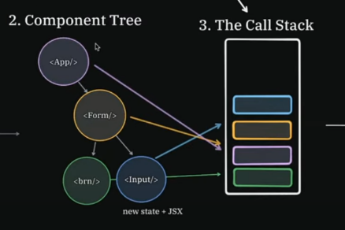
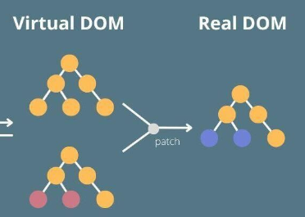
1- What is Reconciliation in React?
Reconciliation in React is the process of updating the real DOM to reflect changes in the virtual DOM, after a component’s state or props change. React performs this efficiently using a diffing algorithm to apply the minimal number of updates needed.
Before React introduced Fiber, rendering was done using the JavaScript call stack, which is synchronous and non-interruptible. This meant that rendering could block the browser, especially for large component trees.
When a component re-renders, React creates a new virtual DOM tree, then compares it to the previous virtual DOM. A naive tree-diff algorithm would take O(n³) time, but React uses an optimized heuristic diffing algorithm that runs in O(n) time. This allows React to detect the minimal set of changes between the two virtual DOM trees and efficiently update the real DOM.
For lists, React uses unique keys to identify which elements have changed, been added, or removed between renders. Using array indexes as keys is discouraged because it can lead to incorrect component state, especially when the list items are reordered. Instead, keys should be unique and stable, like an ID from your data.
But this changed in React 16 and above, where reconciliation is powered by the Fiber architecture, which replaces the old synchronous rendering approach. It builds its own custom stack on the heap (called the Fiber tree), made of units of work. Rendering is now interruptible and can be paused, resumed, or aborted.
When there is a change, React clones the current Fiber tree and creates a new work-in-progress tree. React then uses memoization to compare the previous state with the new one. It compares the new Fiber tree (which represents the new virtual DOM) with the memoized version (representing the old virtual DOM), and follows the same reconciliation steps to determine what needs to be updated.
React Fiber also introduced prioritization to rendering. Updates are categorized into different priority lanes, allowing React to focus on the most urgent work first:
- Discrete events – highest priority (e.g., input, click)
- User-blocking events (e.g., scroll, hover)
- Normal priority (e.g., data fetching, UI updates)
- Low priority (e.g., route transitions)
- Idle/lowest priority (e.g., background pre-renders, non-critical work)

